**Lincolnshire Fire and Rescue firework information**

Please treat this guidance note as additional safety information. Lincolnshire Fire and Rescue believes the following guidelines to be best practice, but we advise that you read the instruction label on each firework carefully as well, before firing.

**Generally**

* Never smoke when handling fireworks.
* Do not leave the fireworks unattended at any time.
* Unpack the fireworks in a safe place away from naked flames and easily inflammable material. Remove all packing material from the firing area.
* Read all instructions on each firework and follow them carefully.
* Keep devices, such as rocket firing racks and set pieces three metres (10 feet) apart to help avoid ignition by stray sparks.
* Never fire across or over the spectators
* Aim or angle aerial fireworks 5 to 10 degrees from the vertical away from spectators so that debris and rocket sticks fall clear and into the fall out zone.
* Do not drink alcohol before setting off fireworks – carelessness can lead to accidents.

**The law**

Please note regulations make it illegal to sell fireworks to anyone under the age of 18. It is also illegal for anyone under the age of 18 to be in possession of fireworks in a public place.

It is an offence to use fireworks between 11pm and 7am except on the following dates, when the curfew begins later.

**Occasion: Curfew Applies:**

Chinese New Year 1am to 7am

Bonfire Night Midnight to 7am

Diwali 1am to 7am

New Year’s Eve 1am to 7am

**Firing**

Always use a safety lighter such as a portfire or a punk stick. Portfires are slow burning firework lighters about 20 centimetres eight inches) long. They may be held in a gloved hand but are preferably attached to a one metre (three feet) cane. Punk sticks are coated lengths of bamboo about 20 centimetres ( eight inches) long, which are an alternative to a portfire and are sometimes provided when you buy your fireworks.

Check the fuse of the fireworks is fully extended and just before firing, carefully remove any paper or plastic protective cover from the fuse. Always light the tip of the fuse with the portfire.

Keep your body well clear of the fireworks. Once lit, turn your face away and retire immediately to a safe distance.

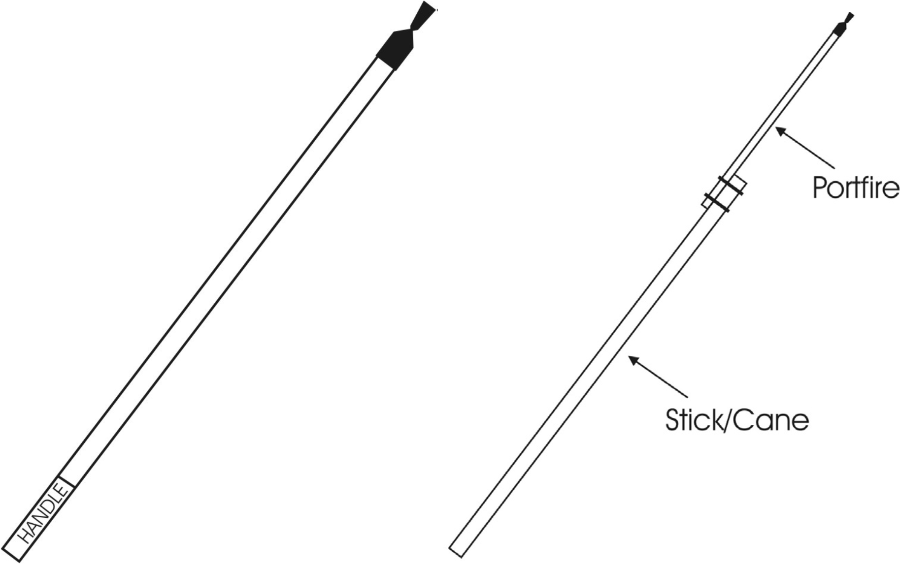

**Before the display:**

**Arrange**

* One person who will be in charge. For large displays this will be someone who has worked on a display before and who has received training on a suitable course.
* A suitable site and obtain any necessary permissions.
* Inform the local Police, Fire and Rescue and Local Authority Safety Advisory group, if near an airport, the CAA. If near the sea, inform the local Coastguard.
* To notify the occupiers of property in the vicinity and advise them to look after children and,or animals who might be affected by noise.
* For Competent Operators to set up and fire the display.
* For Stewards to control the audience (your risk assessment will identify the minimum number).
* The necessary equipment and tools.
* Insurance cover and check to ensure you are covered for these events.
* First Aid Cover.

**On the day**

* Operators must wear safety goggles, a hat or safety helmet and natural fibre clothes with the trousers outside the boots. Ear defenders are also advisable.
* Have buckets of water and, if possible, water type fire extinguisher available.
* Set out the display in daylight, keeping fireworks well separated and fireworks not in use under cover.
* If you have a bonfire, try to arrange for this to be lit after the display and for it to be away from the fireworks fi ring area.
* Light each firework according to its instructions using at arms length.
* Never return to a firework that has apparently failed to light. Leave it until the end of the display and treat as a mis-fi re (see below).
* If you can, talk to the audience before the start, welcoming them; warning them not to enter the firing area at any time and advising them of the noise.
* Stopthe display if any unauthorised person enters the display area.
* Remember that the organiser is responsible for the safety of the spectators. Make sure all personnel know what to do in an emergency.
* If the wind is stronger than a light breeze you may wish to consider postponing the event or firing a test shot in daylight, before the audience arrives, to see where the debris is falling.

**After the display**

* Do not permit anyone in the firing area until all the fireworks have been checked as safe, rendered harmless and cleared away.
* Treat all mis-fires as dangerous – they might still go off.
* Leave all mis-fires for at least 30 minutes before dowsing thoroughly with water. Then remove from the site and immerse in water overnight - in a bucket or barrel.
* Under no circumstances throw spent or partially spent fireworks onto a bonfire.
* Check the site the following morning, filling holes and making sure all debris is thoroughly cleared.

**The site**

* The site should be arranged so that the spectators are on only one side of the firing area, preferable upwind. This makes them easier to control and gives them a better view.
* Keep well clear of buildings, trees and overhead power cables. Clear any undergrowth or long grass if necessary.
* Fence off an area approximately 40 to 50 metres square, depending on the size of the display, as the firing area.
* Provide a second fence to keep spectators at least 25 metres away from the nearest firework. N.B. For displays using larger fireworks, a minimum of 50 metres is recommended. Contact your supplier to confirm separation distances. Double these distances if the wind is blowing towards the spectators, or alternatively consider cancelling the event if in doubt.
* Arrange for a fall-out zone for aerial fireworks. This should be clear of all people, vehicles, building, stores, or anything flammable.
* Spectators must not be permitted to watch from the rear.

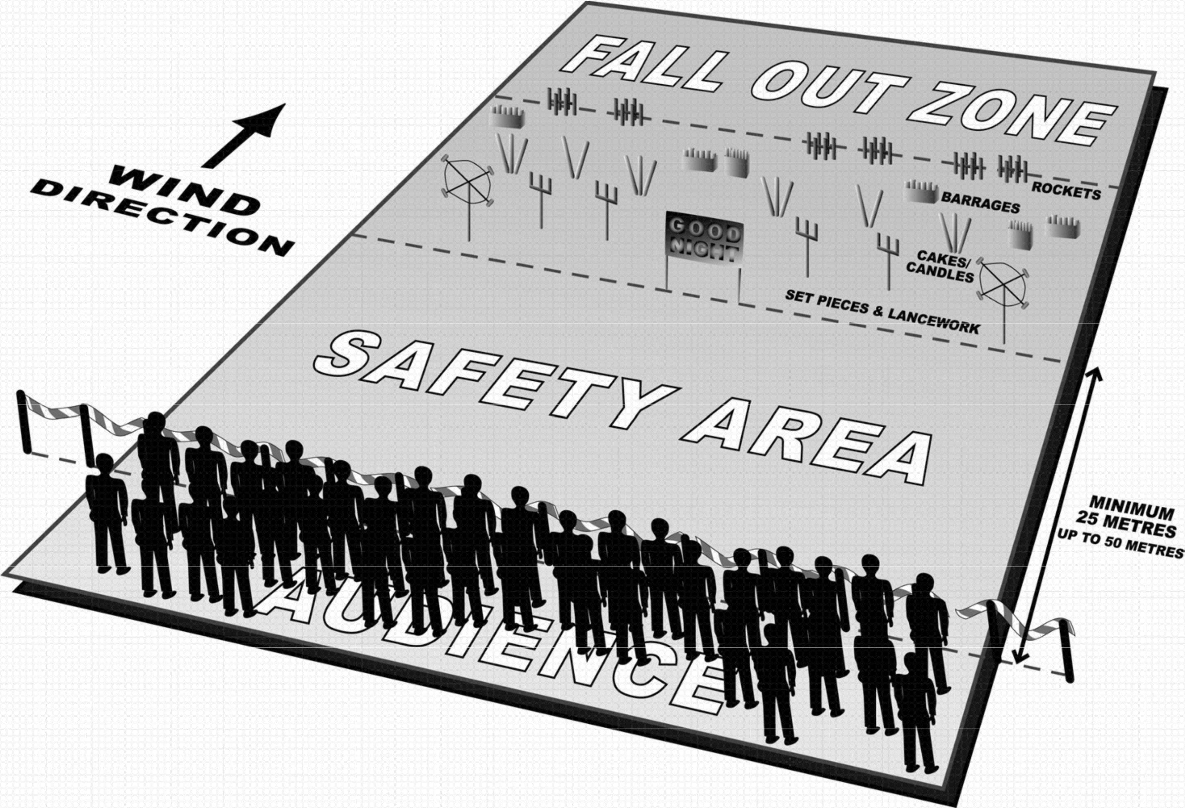

**Firing order**

Plan your site in advance and set out your fireworks so you can move safely from one item to the next keeping a safe distance from active fireworks. Clearly numbering the items helps you to remember the order in the heat of the display.

Continuity is the key to a smooth and successful display. In designing the display use set pieces or ground based fireworks such as wheels and waterfalls as a natural break between aerial sequences. Start and end the display with a dramatic effect such as a large rocket, mine or one of our finale cakes.

Use candles and multi shots to give the display structure and duration, and punctuate throughout with mines and rockets. Two firers could create pleasing combinations, but remember that you will get through your fireworks more quickly.

**Duration**

Do not try to drag out the display - firework displays always seem longer than they actually are. A maximum of 20 to 30 minutes should be the limit even for the biggest display, while 10 to 15 minutes of reasonably continuous action should be fi ne for the smaller event. Aim to fire mines and rockets at a rate of one every 10 to 20 seconds; barrages and candles every 30 to 40 seconds and allow one minute for wheels and set pieces. The larger the display, the shorter the interval between items.

**Tips and best practice**

If a label says ‘Attach securely to an upright post’ this post should be positioned between the audience and the fireworks so that if the firework breaks free of the fixings, it will fall away from the audience and thus reduce the risk of injury. (See diagram below).

Think about the wind when setting up; not just whether the debris or fallout will stay within your fall out zone, but also the order the fi reworks are laid out – make sure the next item to be fired is upwind of the last. This way smoke and debris is less of a hazard as it should be drifting away from you.

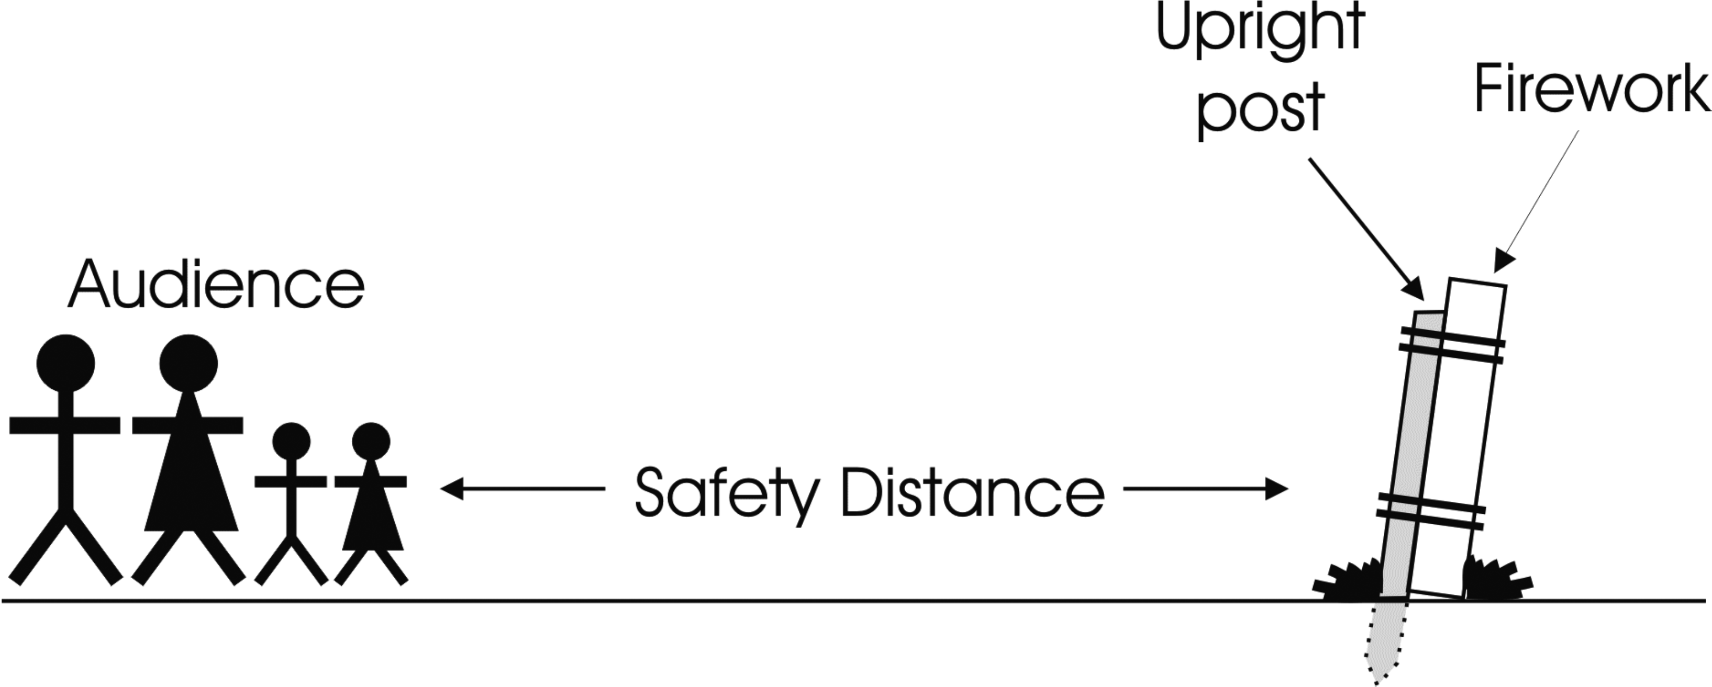

**Always be safe, not sorry**