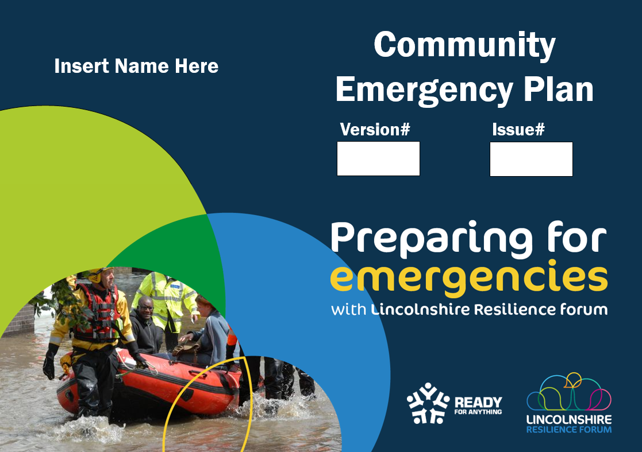

Insert Name
READY
FOR ANYTHING
Version

Part 1
Operational
Contents
Distribution List 3
Mission Statement 3
Using this Emergency Plan 5
Activation 5
Information Flow 6
Important Contact Information 7
Key Actions 10
Volunteer Briefing 11
Local Hazards & Threats 14
Local Flood Map 15
15
LRF Public Information Map (PIMap) 16
Community Incident Room 17
Emergency Support Centres 18
Community Emergency Box 19
Vulnerable People 19
Snow Clearance 20
Appendix 1- ETHANE REPORT 21
Appendix 2 - Incident Log 22
Appendix 3 - Emergency Support Centre Roles 23
Appendix 4 26
Record of Amendments 26
Appendix 5 27
Plan Publication and Maintenance 27
Appendix 6 28
Data Protection Act 2018 28
Appendix 7 29
Training, Exercising and Skills records 29

Version 1 with effect from: | Feb 2024
Review Date: | January 2025

This plan is a controlled document which contains information to be used during an emergency affecting the communities within Insert name Parish Council.
To comply with the Data Protection Act 2018 the information contained within this document should not be disclosed to any unauthorised person without the express permission from the plan owner and those listed within the plan as having a specified role.

Distribution List

Name | Address | Contact Number | Email
Emergency Planning Unit | Lincolnshire County Council | 01522 843406 | LincsEP@lincolnshire.gov.uk
Insert Details.
Records of Amendments
Plan history is stored within the appendices of this plan. Please click here to view.
Plan Publication & Maintenance. Please click here to view.
Data Protection. Please click here to view.
Training Records. Please click here to view.

Mission Statement

Disasters or major emergencies can strike suddenly, unexpectedly and anywhere. Making a plan now will reduce the impact of any emergency on our community and help ensure our response is effective and proportionate.
The purpose of this Community Emergency Plan is to help prepare the community to be ready for an emergency, in case the emergency services and/or relevant authority support are delayed due to the scope and nature of the emergency. This will be achieved by building resilience within the community, using our existing resources in the most efficient and successful way. Our aim is to provide expertise and voluntary support that is safe and proportionate within Welton by Lincoln Parish Council boundaries and or our neighbours that enhance that of responding agencies. This is an all hazards plan which includes flooding.

This Community Emergency Plan has been agreed and signed as fit for purpose – acting as a living document - by the Chairperson of the Parish/Town Council, the Community Emergency Team Leader and/or their Assistant.

Signatures
Role | Insert Details. |  | Role | Insert Details.
Name |  |  | Name
Date |  |  | Date
Role | Insert Details. |  | Role | Insert Details.
Name |  |  | Name
Date |  |  | Date
Role | Insert Details.
Name
Date

Section 1

Using this Emergency Plan
This plan has been developed to assist your community in an emergency. It should be used as a tool to focus your response to aiding the welfare of your community. It is an all hazards response plan.

Activation
This Plan will be activated when at least two members from the below list of people drawn from the Emergency Planning Group consider it necessary to take action in response to an incident, and when action cannot be taken effectively without triggering the arrangements outlined in this document. If this plan is activated key actions in Section 2 should be followed. In the event of this plan being activated the LCC EPU Duty Officer should be notified immediately.
Emergency Planning Group members who can activate the Plan:
Emergency Planning Group members who can activate the Plan:
Name | Role | Contact
Insert Details.

In the absence of the above members, anyone member of the emergency planning group can activate the group to discuss actions but the Emergency Planning Unit must be informed using the telephone number at the bottom of this page. If in doubt, it is better to activate and stand down than try to activate when in response.

Information Flow
Lincolnshire Emergency Planning & BC Service 01522 843406
Environment Agency
0800 80 70 60
Emergency Services
999
Emergency Planning Group
Wider Emergency Planning Group
Community
Typical Single Point of Contact Model
KEY
❶ Life threatening situation call 999 immediately
❷ Once your plan is activated: inform and maintain contact with the Emergency Planning & BC Service
❸ For river/sea flooding information contact EA
❹ For surface water issues contact LCC Lead Local Flood Authority
Lead Local Flood Authority
01522 782070
Out of hours 01522 782082
❷
❶
❸
❹
Large Scale incidents EPO will make contact with you

In an emergency, getting the right information is critical to a well-co-ordinated response. Use this flowchart as a reference.
Whether you activate your plan or the on-call Emergency Planning Duty Officer (EPO) requests you to activate your community plan – please ensure you maintain contact with the EPO. Additional resources and voluntary groups cannot be activated to support you unless you keep EP informed.
The EPO will liaise directly with the emergency services Incident Commander (IC) within the inner cordon of the incident – and can relay your concern, identified vulnerable people and your group’s actions to date.

Important Contact Information
Important Telephone Numbers, Postal and email addresses
Insert Details Coordination Team
Area & Name | Organisation / Role | Contact information
Community emergency volunteers who can be contacted are:

Emergency Notify text alert registered phones
Insert Details.
Out of Parish Contact numbers
Insert Details District Council
(1) Working Hours
(2) Outside Normal Hours

Lincolnshire Police
(1) Emergency Calls | 999
(2) Non-Emergency Calls | 101
(3) general Enquires | 0300 111 0300

Lincolnshire Fire & Rescue
(1) Emergency Calls | 999

East Midlands Ambulance Service (EMAS)
(1) Emergency Calls | 999
(2) General Enquiries | 08450 450222

Lincolnshire County Council Emergency Planning & Business Continuity Service
(1) Emergency Planning Unit | 01522 843406
Environment Agency
(1) General Enquires (Mon – Fri: 8am – 6pm | 03708 506 506
(2) Incident Hotline (24 hours) | 0800 80 70 60
(3) Floodline (24 hours) | 0345 988 1188

Lead Local Flood Authority

- Working Hours - Flood Reporting Line* | 01522 782070
- Outside Normal Hours* | 01522 782082
*for reporting flooding issues

Neighbouring Parish Council contacts

- Insert Details.

Utility Companies
(1) Electricity – Central Networks | 0800 056 8090
(2) Gas – National Grid | 0800 111999
- Anglian Water | 08457 145145  0800 771881
- Severn Trent Water | 0800 7834444

Internal Drainage Boards
- Witham Third District IDB | 01522 697123

Maritime Coast Guard
- Emergency calls | 999
- Humber Coastguard Operations Centre | 01262 672317
RNLI
(1) RNLI Skegness | 01752 763011
(2) RNLI Mablethorpe | 01507 447848
Coastwatch
(1) Skegness Coastwatch Station (NCI) | 07902 076605
(2) Mablethorpe Coastwatch | 07930 731671
- Chapel Point | 01754 874311

Section 2

IMPORTANT NOTE: NEVER PUT YOURSELF AT RISK OF HARM
Before Responding

- THINK - is it safe for us to take action?
- COMMUNICATE – with your team, your families and the Emergency Planning Duty Officer (EPO)
- PLAN – what are we trying to achieve?
- TAKE ACTION – as agreed by the whole group and/or the Emergency Planning Duty Officer. This may include taking no action!

Key Actions
Priorities will be given to emergency shelter (dry and warm), water and food.

- Gather as much information about the situation as possible following the ETHANE Principle (See initial call taking log – Appendix 1)

  - Exact location of emergency
  - Type of incident
  - Hazards that are present or anticipated
  - Access routes for the emergency services
  - Number of people and/or properties involved (estimate)
  - Emergency services or other organisations already in attendance or required
    - e.g. Police, Fire, Ambulance, Utilities
IF THE SITUATION IS LIFE-THREATENING: DIAL 999 WITHOUT DELAY
- Make contact with the emergency services and Lincolnshire Emergency Planning Unit. Inform them of the contact number and location of the Emergency Planning Group

- Take control until the emergency services arrive, if they are able to attend straight away

Contact additional members of Insert Name wider Emergency Planning Group
- Instruct everyone to follow any advice from the emergency services

- At all times, be aware of your own safety and the safety of those around you – never put yourselves at risk of harm. Do not enter any flood water, attempt any form of rescue operation, or attempt to clear blocked drains, gullies, ditches or watercourses

- Consider whether you can work safely and effectively from your current location or whether you need to move to the Village Hall. If working out of doors, only do so if weather conditions permit.

- Consider if it is necessary to open emergency shelter (Village Hall). Arrange for supplies of food and drink (if not readily available)

- Arrange for local residents to be warned of any dangers (if safe to do so)

- Liaise with the EPO to consider if it is necessary to open an emergency shelter? The EPO will request whether this is required from the Incident Commander(IC). The IC may identify a location or ask this of the EPO. You may be asked to establish the centre prior to the EPU and their resources arriving.

- Arrange for contact to be made with those people who may need more support as identified in this plan; offer advice and assistance if required and only if it is safe to do so

- This about what resources you may need if operating a place of safety and make available as necessary

- Tune into your local radio station (BBC Radio Lincolnshire/Radio Humberside/ LincFM) and advise the community to do the same.

- Maintain regular communication with all Emergency Planning Group members, and Lincolnshire County Council’s Emergency Planning Unit

Volunteer Briefing
Before deploying volunteers, all should receive briefings as to the current and expected situation and be advised as to what is expected of them before they are mobilised. All volunteers have the legal responsibility to take reasonable care for their own Health and Safety and that of others that may be affected by their actions. Any incidents or hazards should be immediately reported back to the community emergency planning coordinator, recorded and then forwarded onto the LCC EP Duty Officer.
Briefings Template
- Situation Awareness – following the ETHANE Framework (See Key Action) brief all volunteers on the current situation. Frequency of updating – agree a frequency of updating volunteers.
- Environmental Awareness – ensure all volunteers are aware of current weather forecasts and environmental challenges – always take precautions to ensure volunteers remain well informed and suitable dressed. In some circumstances volunteers should not venture out into elements that would put them at increased risk of harm. Always maintain communication throughout operations and report any changes or disruptions to you activities to the community emergency planning coordinator.

- Expectations - what are your expectations? Can you explain these to your volunteers simply? Have these been explained to you by the emergency services/EPU? How will these be communicated to your volunteers when they have been deployed? Ensure you have a clear route to how this information will be implemented.

- Tasks - brief volunteers on specific tasks that they will be allocated, for example, door knocking, meet and greet etc

- Times – how long will volunteers be expected to undergo tasking? Is there a rota system in place?

- Welfare – what provisions are available to volunteers undertaking tasks , for example, refreshments, meals, breaks etc. what other support is available to them, e.g mentoring, physiological support etc.

- Communication - how will volunteers communicate with the coordinating group, each other and those people who they are supporting?

- Safeguarding – Safeguarding is the action of protecting people’s health, welfare and human rights, enabling them to live free from abuse, harm and neglect. Everyone has a role to play in safeguarding and promoting the welfare of any child, young person or adult at risk that they may come into contact with. If a volunteer has concerns surrounding safeguarding issues they should report it immediately to their coordinator who in turn will notify LCC EPU. Safeguarding is there to protect you as well – please adhere to best practice. A copy of the LCC safeguarding brief for volunteers is held within the community emergency box.

- Reporting incidents & Accidents – how this is achieved and who is responsible for it? An accident form is held within the community emergency box

- Health Protection – In certain circumstances (human and animal pandemics) health protection measure may be implemented. Please ensure all volunteers are fully briefed as to acceptable behaviours and practices e.g. face coverings, hand washing, social distancing, animal protection zones etc.

- Stand down – who will make this decision and how will this be communicated to all volunteers?

Assessed in Risk for Insert Name
Pandemic Flu | Assessed Nationally and Regionally as our Highest Threat.
Inland Flooding | Insert Details.
Severe Weather | Insert Details.
Transport Accidents | Insert Details.
Industrial Accidents | Insert Details.
Loss of Critical Infrastructure | Insert Details.

Local Flood Map
THIS IS AN EXAMPLE ONLY
Scan or click on the QR code to access local flood risk mapping.

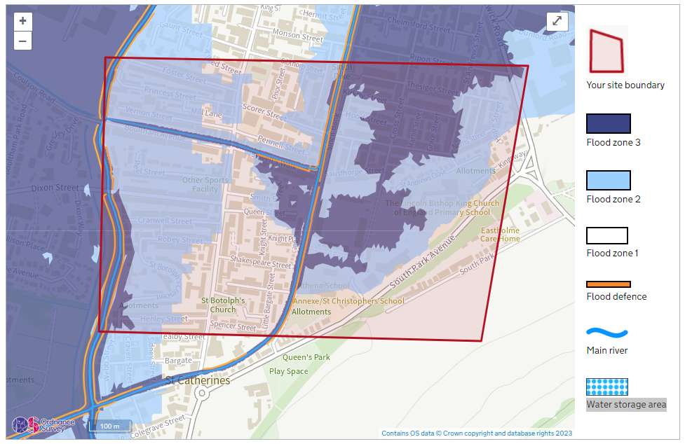
Once page opens, scroll down to map and click on the arrows in the top right hand corner to expand. From here you will be able to explore your local area, save your map to PDF and print if required. You will also be able to zoom into the map down to property level.
IMPORTANT NOTE
This resource shows where water is likely to pool in the event of a flood from rivers, sea or surface water events not that it will occur. From this same resource, you will be able to access information to assess surface water flood risk and ground water flood risk for your community. If you have any questions please contact lincsep@lincolnshire.gov.uk
Area 1. EXAMPLE
Area 2. EXAMPLE
Area 3. EXAMPLE
Area 4. EXAMPLE
Area 5. EXAMPLE

LRF Public Information Map (PIMap)
More detailed community mapping can be accessed by click or scanning the QR code below.

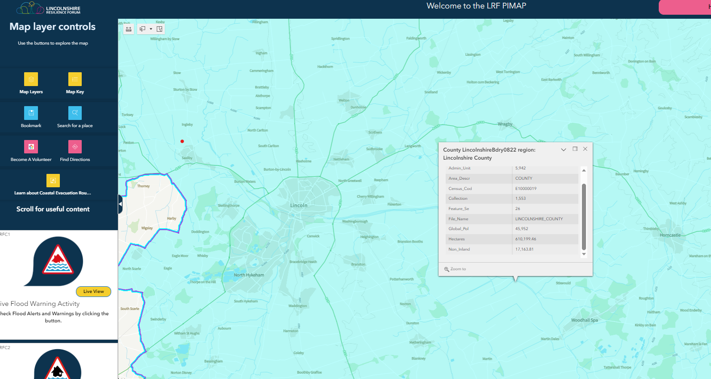

IMPORTANT. For flood related actions please go to Flood defences
Section 3

Community Incident Room

If the Emergency Planning Group is brought together to discuss the community response, it has been agreed that they will meet at:

Insert Details
Please insert full postal address

///What3Words: Insert Details

The key holders for this building are:
Name | Mobile | Home/work

Insert Details
Please insert full postal address
///What3Words: Insert Details.

The key holders for this building are:

Name | Mobile | Home/work
Insert Details.

Community incident room continued.
Insert Details
Please insert full postal address
///What3Words: Insert Details

The key holders for this building are:
Name | Mobile | Home/work
Insert Details

Emergency Support Centres

In an emergency the following location has been designated as a potential Temporary Emergency Shelter. This is in addition to those already identified by Lincolnshire County Council Emergency Planning Unit.

If required, the Emergency Planning Group will activate the following locations to be used as a primary place of safety.

Location 1

Insert Details.
///What3Words: Insert Details.

The key holders for this building are:

Name | Mobile | Home/work
Insert Details. | Insert Details. | Insert Details.
Insert Details. | Insert Details. | Insert Details.
Insert Details. | Insert Details. | Insert Details.

Capacity of shelter: Insert Details.
Cooking Facilities: Insert Details.
Parking facilities: Insert Details.
WIFI Access: Insert Details.

Other facilities; - Insert Details.

Location 2.

Insert Details.
///What3Words: Insert Details.

The key holders for this building are:

Name | Mobile | Home/work
Insert Details. | Insert Details. | Insert Details.
Insert Details. | Insert Details. | Insert Details.
Insert Details. | Insert Details. | Insert Details.
Insert Details. | Insert Details. | Insert Details.
Insert Details. | Insert Details. | Insert Details.
Capacity of shelter: Insert Details.
Cooking Facilities - Insert Details.
Car Parking arrangements: Insert Details.
WIFI Access: Insert Details.

Other Facilities – Insert Details.

If more locations have been identified please add them to this section of the plan.

Community Emergency Box

An Emergency Box is located at the following location and contains standard LRF issued items.

Insert Details.

///What3Words: Insert Details.
and

A full list of kit contents can be found inside the box along with a sign off sheet for when the kit was last checked. Replacement items for each kit is the responsibility of the community emergency planning group.

In addition to the community emergency box, Welton Parish Council also have a store of equipment to be used in response to flooding in the community. This includes:

Item | Quantity | Last checked
Insert Details | Insert Details | Insert details
Insert Details | Insert Details | Insert details
Insert Details | Insert Details | Insert details
Insert Details | Insert Details | Insert details
Insert Details | Insert Details | Insert details
Insert Details | Insert Details | Insert details
Insert Details | Insert Details | Insert details
Insert Details | Insert Details | Insert details
Insert Details | Insert Details | Insert details
Insert Details | Insert Details | Insert details
Insert Details | Insert Details | Insert details

Communities cannot close roads but can place warning signs to alert road users of flooding. Please ensure the community abides to legislation. DO NOT PUT YOURSELVES OR MEMBERS OF THE PUBLIC AT RISK.

Vulnerable People

Please list known locations of vulnerable people or places here. Only list locations not names and contact details unless already within the public domain. For example, a nursing home etc.

Insert Details.

Note ; Emergency Response Team have direct access into the Adult Social Care Team to identify vulnerable individuals and available resources

Snow Clearance
The full snow clearance plan can be found at Appendix Please insert details here. Equipment required to clear snow and ice is stored at the following locations:

Grit Bins Locations in the community are as follows

Insert Details.

Flood Defence (if applicable)

Working with emergency services and the Lincolnshire Resilience Forum (LRF), Insert Details
aims to mitigate the impacts of flooding, as practicably as possible, on the residents of Insert Details and its surrounding area. This will be achieved through the delivery of:

- Information and guidance on how to protect properties from flooding and what to do in the event of a flood occurring.
- Monitor Insert Details feeding back any information to authorities about restrictions to flow, damage to bank defences and or overtopping incidents.
- Provision of guidance to property owners on riparian ownership and the role they play in maintaining their watercourse to minimise the potential of flood risk.
- Activation of the Insert Details Community Emergency plan when required to respond to local flooding events and to liaise with the wider LRF and emergency services.

Appendix 1- ETHANE REPORT
Initial Call Log following the “ETHANE” format
This form is intended to be used as an aide memoire / prompt when responding to an incident and should be completed along with an incident log.
DETAILS OF INCIDENT
Exact Location

Type of Incident

Hazards Present – Details

Access

Number and nature of casualties/fatalities

Emergency Services involved

Name of Emergency Planning Officer notified
Activation of Community plan and staff notified

Date of Initial Call | Time: | Time of Call to EP:
If fatalities are suspected and the Emergency Services are not at the scene, please contact the Police in the first instance on 999 to report the situation. Please take advice from the Police on what further action to take. Issues to consider are tampering with forensic evidence and the contamination of a potential crime scene.

Appendix 2 - Incident Log

INCIDENT ………………………………………………………………….
…………………………………………………………………………………
DATE………….……………………………
PAGE………1……………OF……………15……….
PERSON COMPLETING LOG –……………………………………………….
Was a rest centre set up? Yes/No
What location, date and time? Also note the time of the decision to open a rest centre…………………………...............................................................................
What date and time was it activated? Also note the time of this decision....................

SER NO. | DATE/TIME | DETAIL

If you require further space, please make copies of this form making sure your number and sign each page in sequence

Appendix 3 – Responding to flooding

Flood alerts
On receipt of a Flood Alert
Up to 5 days in advance of possible flooding.
1. | - Monitor level gauges.  - Trigger point for escalation is when the gauge reads XXXXX Please insert details  - Insert exact location of gauge \\\what3words
2. | - Monitor the Environment Agency river gauges. Click here to access.
3. | - Ensure all members of the community emergency response group are aware of the situation.
4. | - Consider actions as required.
5. | - Monitor Flood Alerts via EA. Click here to access.

Flood Warning
 | On receipt of a Flood Warning
1. | - Notify all members of the community emergency group and flood action group.  - Monitor level gauges.  - Trigger point for escalation is when gauges reads XXXXX Please insert details  - Insert exact location of gauge \\\what3words
2. | - Start an incident log considering the following:  - Discussions  - Actions  - Rational  - Expenditure  - Accidents
3. | - Consider if the emergency plan needs to be activated.
4. | - If activating, follow activate process in plan  - Ensure the Emergency Planning Duty Officer is notified using the contact provided.  Out of Hours number will be provided once the plan is complete.
5. | - Activate the community emergency incident room.
6. | - Monitor the Environment Agency river gauges. Click here to access
7. | - Consider the following actions:  - Check flood mitigation equipment  - Assign roles to volunteers  - Support people who may need help to move furniture etc.  - Ensure vulnerable people are kept informed  - Warn and inform residents to take action.  - Liaise with the EP duty officer  - Deploy flood mitigation equipment to where it will be most effective  - Put on standby a temporary place of safety in case of evacuation.
8. | - If required, place flood warning signs.
9. | - Maintain communication with the EP duty Officer  - Maintain communication with the community.
10. | - Follow all instructions given by emergency services.
11. | - If required, open a temporary place of safety and assign volunteers to roles outlined in Appendix 4.
12. | - Report all flooding incidents to the lead local flood authority 01522 782082

Flood Warning
 | On receipt of a Severe Flood Warning
1. | - Take immediate action, Risk to life  - Monitor level gauges.  - Trigger point for escalation is when the gauge reads XXXXX Please insert details  - Insert exact location of gauge \\\what3words
2. | - Start an incident log considering the following:  - Discussions  - Actions  - Rational  - Expenditure  - Accidents
3. | - Activate the emergency plan
4. | - Notify the Emergency Planning Duty Officer
5. | - Activate the community emergency incident room.
6. | - Monitor the Environment Agency river gauges. Click here to access
7. | - Take the following actions:  - Check flood mitigation equipment  - Assign roles to volunteers  - Ensure vulnerable people are kept informed  - Liaise with the EP duty officer  - Deploy flood mitigation equipment to where it will be most effective.  - Warn and inform residents to take immediate action.  - Open a temporary place of safety and assign roles as outlined in Appendix 4.
8. | - Deploy flood warning signs.
9. | - Maintain communication with the EP duty Officer  - Maintain communication with the community.
10. | - Follow all instructions given by emergency services.
11. | - Report all flooding incidents to the lead local flood authority 01522 782082
NEVER PUT YOURSELVES IN DANGER. DO NOT ENTER FLOOD WATER. STAY IN COMMUNICATION WITH EACH VOLUNTEER THROUGHOUT INCIDENT.

Appendix 4 – Sandbags
Sandbags are not the most effective means of preventing flood water. To be affective, sandbags must be lined with a waterproof membrane. Anything can be used as a sandbag including pillow cases filled with soil. Sand is not a requirement as a filling.
Residents are advised to seek bespoke flood mitigation for themselves however, in emergency situations, sandbags can be requested from Highways 01522 782082. There are a number of commercial stockists that can supply sandbags, sandbag alternatives and other flood mitigation.
MERCHANT | ADDRESS | AREA | TELEPHONE | BAGS | SAND
Insert Details
Sandbags should not be removed without prior permissions being obtained from property owner.

Appendix 5 - Emergency Support Centre Roles

Emergency Support Centre Roles (Initially, until responding agencies arrive)
There are many roles to consider when setting up and managing a place of safety, below are listed the main priorities in order along with their associated responsibilities. Full training is available for each role.
EVACUATION CENTRE MANAGER (ECM) - To be nominated by EPGTL / Dep EPGTL if required
1. |  | MAIN ROLES AND RESPONSIBILITIES:  - The effective management of the centre including teams and resources – consider Dep ECM, Meet and Greet Team, Loggist, Registration Team, Welfare Team roles if required.  - Responsible for the safety and security of the centre  - Co-ordination of volunteers within the centre  - Consider food, warm drink, blankets, books etc  - Receive and interpret incoming information  - Chair management team meetings (initial meeting and then as a member of the management team once responders arrive)  - Ensure they have overview of all activities at the centre  - Problem-solve as issues arise  - Escalation through appropriate channels (EPO or CVC cell if operational)  - Single point of contact for emergency services and other responders  - Ensure effective two-way communication
2. |  | KNOWLEDGE AND SKILL REQUIREMENTS:  - Good leadership and co-ordination skills  - Good communication and interpersonal skills  - Competent with IT and record keeping  - Understand tasks and processes  - People and conflict management  - Leadership skills  - Co-ordination and delegation  - Discretion  - Situational awareness  - Dynamic assessments  - Trained and competent
3. |  | REPORTS TO:  - Emergency Group Coordinator and/or LCC Emergency Planning Duty Officer / CVC cell
DEPUTY EVACUATION CENTRE MANAGER(S) (DECM) - If required to be nominated by ECM
1. |  | MAIN ROLES AND RESPONSIBILITIES:  - Provide support role to centre manager and when required lead  - Have overall view of activities  - Provide briefings to volunteers and evacuee
2. |  | KNOWLEDGE AND SKILL REQUIREMENTS:  - Good leadership and co-ordination skills  - Good communication and interpersonal skills  - Competent with IT and record keeping  - Understand tasks and processes  - People and conflict management  - Leadership skills  - Co-ordination and delegation  - Discretion  - Situational awareness  - Dynamic assessments  - Trained and competent
3. |  | REPORTS TO:  - Evacuation Centre Management
MEET AND GREET TEAM - If required to be nominated by ECM
1. |  | MAIN ROLES AND RESPONSIBILITIES:  - Provide initial greeting to emergency evacuation centre  - Welcome and guide evacuees through process  - Identify any initial concerns and escalation to appropriate method  - Keep track of those entering and leaving the Centre where possible.
2. |  | KNOWLEDGE AND SKILL REQUIREMENTS:  - Good communication and interpersonal skills  - Compassion and empathetic  - Dynamic triaging  - Record management / keeping  - Access to translation services
3. |  | REPORT TO:  - Deputy Evacuation Centre manager
LOGGIST - If required to be nominated by ECM
1. |  | MAIN ROLES AND RESPONSIBILITIES:  - Provide administration and loggist support to the centre and the management team  - Log any issues, actions and decisions  - Minute any meetings that take place (initially – responders will take responsibility for this once arrived at scene)  - Collate registration information (initially – responders will take responsibility for this once arrived at scene)  - Keep records of any donations made at the centre (initially - responders will take responsibility for this once arrived at scene)
2. |  | KNOWLEDGE AND SKILL REQUIREMENTS:  - IT literate  - Loggist and minute taking skills  - Good communication skills  - Record keeping skills  - Flexibility and dynamic problem solving
3. |  | REPORT TO:  - Evacuation Centre management
REGISTRATION TEAM - If required to be nominated by ECM
1. |  | MAIN ROLES AND RESPONSIBILITIES:  - Co-ordinate and carry out the registration process for evacuees  - Triage and escalation to evacuation centre manager (Initially)  - Report back information to Loggist for collation  - Work with other agencies to collate and identify missing or vulnerable persons (once on scene)
2. |  | KNOWLEDGE AND SKILL REQUIREMENTS:  - Good communication and interpersonal skills  - Compassion and empathetic  - Dynamic triaging  - Record management / keeping  - Organisational skills  - IT literate (desirable)  - Data gather and inputting skills (desirable)
3. |  | REPORT TO:  Evacuation Centre management
WELFARE TEAM - If required to be nominated by ECM
1. | MAIN ROLES AND RESPONSIBILITIES:  - Provide emotional welfare to evacuees and provide as much information as is available in support of the Deputy Evacuation Centre Manager.  - Provide assistance for evacuees with pets.  - Listening ear  - Engagement with new arrivals and provide informal wellbeing check ins / walk arounds  - Identify and deal with any concerns and escalate through appropriate channels  - Deal with practical wellbeing issues I.e. refreshments
2. | KNOWLEDGE AND SKILL REQUIREMENTS:  - Good communication and interpersonal skills  - Compassion and empathetic  - Dynamic triaging  - Psychosocial support - desirable  - Positivity  - Confidentiality
3. | - REPORTS TO:  Evacuation Centre Management

Appendix 6 – Recovery
Following incidents in the community, WPC will support with recovery efforts to help the community return to a new state of normality. Throughout this process liaise with the emergency planning duty officer to ensure recovery actions are fed into any wider recovery activities.
Recovery Actions
1. | Maintain a log
2. | - Take photographs of impacts
3. | - If required, and or possible, record flood water depth (approximation, do not enter flood water)
4. | - Support agencies with community impact assessments and data collection. This is used for investigation and to ensure residents get the right support from agencies.
5. | - Support residents with clearing debris.
6. | - Do not throw anything away until it has been photographed and any insurance has been consulted.
7. | - Support with community information sessions
8. | - Participate in any agency debriefs
9 | - Update emergency plan with lesson learnt.

Appendix 7

Record of Amendments
Plan History
Record of Amendments / Revision of Plan

Date | Details of amendments / revisions | Amended / revised by
January 2015 | Template revision and formulation | EPO Steve Eason-Harris
January 2015 | Comments on revised template | EA Rachael McMahon / Melanie Byrne
May 2015 | Front Cover design update | Boston Borough Council
January 2016 | Template amended to incorporate activation flow chart and key contacts list | EPO Steve Eason-Harris
June 2016 | Addition of community maps and incident log sheet | EPO Steve Eason-Harris
October 2016 | Updated to standard template – addition of community mapping, incident log sheets – returned to community for sign off and publication | EPO Steve Eason Harris
December 2018 | Front cover change to reflect changes to the community risk register | EPO Steve Eason-Harris
August 2019 | Version 9 template formulated | EPO Steve Eason-Harris
March 2020 | EP out of hours emergency contacts updated | EPO Steve Eason-Harris
February 2022 | EP Template update | EPO Steve Eason-Harris
July 2023 | Plan review and update | EPO Steve Eason-Harris
August 23 | PIMap inclusion | EPO Steve Eason-Harris
November 2023 | Flood information updates | EPO Steve Eason-Harris
March 2024 | Amended the EP out of hours call out number | EPU

Appendix 8

Plan Publication and Maintenance

It is important that this operational plan and the Community Resource Directory, if one has been developed, are kept up-to-date and that all members of the Emergency Planning Group are reading from the same version. It is good practice to update your plan on an annual basis and/or, as and when changes occur within the group and/or, through lessons learnt through exercise and/or real world events.
Electronic copies of both documents will be stored by:
Insert Details.
Paper copies are kept by:
Insert Details.
A redacted web version of the Community Emergency Plan has been posted on:
Insert Details.

Plan Maintenance Review

The owners of this plan should make sure that all the people involved in its development are aware of their roles, and know that they might be contacted during an emergency at short notice.
This plan will be exercised annually by the Emergency Planning Group with the support of LCC EPU and as part of any wider Lincolnshire County Council / Lincolnshire Resilience Forum multi-agency exercise. The lead coordinator for the community emergency planning group and/or the chairperson of the town or parish council will have the responsibility for arranging the community exercise.
The plan will be reviewed annually or whenever changes occur in membership or circumstance. During the review every section of the plan will be checked for accuracy (e.g. phone numbers, resource list etc).
Any updates or lessons learned from exercises should be approved by members of the Insert Details. Emergency Planning group and the parish councils before changes are made.

Appendix 9 Data Protection Act 2018
This community emergency plan remains the property of the community and therefore any information collected in its creation is the responsibility of the group. Personal data is collected for the following purposes:
- In the event of the plan being triggered, the group, by agreement, agree to share their contact details with the local emergency planning group and LCC Emergency Planning Unit for use in a warning & informing / coordination capacity before, during and after emergency.
- Where necessary, Lincolnshire County Council Emergency Planning may share this data with partner agencies and/or the emergency services. We only share information where necessary to protect your vital interests and/or the vital interests of others for the purpose of emergency response and the recovery process in accordance with Data Protection. For more information on how Lincolnshire County Council processes your data, please request a copy of the LCC Privacy Notice by clicking here.

Indemnity Insurance

All volunteers are expected to read and sign the Lincolnshire County Council Indemnity Insurance form before undertaking any voluntary roles on behalf of the authority. To access the form please click here or scan the QR code below.

Appendix 10

Training, Exercising and Skills records

Training & Skills
Date | Name of Individual | Training Received
Insert Details.

Exercises
Date | Exercise | Outcome
Insert Details.

